GREET MEDICAL PRACTICE

PATIENT REPRESENTATIVE GROUP REPORT 2012-13

The Patient Representative group was formed at Warwick Road Medical Centre which has now moved to bigger premises and is named as Greet Medical Practice. The group was first established in June 2011 to understand the views of the patients on the services the Practice offers and also changes taking place in the NHS. The patient group is an open membership group that has a number of patients already that take part and encourages involvement and attendance from patients in all areas of the practice community to benefit both the patients and the practice. The group has 15 members from a list size of 4.465 and meets every three months to discuss e.g. access to the services the practice offers, local health needs, patient demand, changes to the practice and works closely with the doctors and practice manager to enable patients to provide feedback on a range of health related issues.
Profile of Members of the Patient Group
Evan Padmore, Afro-Caribbean – Age 76 .Speaks English and joined the practice in 1999, He lives locally and is a carer for his wife. Patient is a regular attendee of the practice and is routinely involved in escorting his wife to the surgery for appointment etc. Mr Padmore is aware of the changes that have taken place in the practice in the past and future and is also known to the community very well. He has played an active role in the PPG sharing his knowledge and input.
Bridget Bradshaw – Aged 82, speaks English, very healthy and active has been a patient with the practice since it was first established. Patient is aware of the changes that the practice has made to improve and succeed.
Sonal Arethewala, Aged 37, Came to the UK from India 10 yrs ago and is a Christian, Speaks fluent Gujarati, and English and understands Hindi. Works as A Care Assistant in a Nursing Home as well as at the Practice as a Health Care Assistant.
Shah Nahar – Aged 58, speaks Bengali, came from Bangladesh and is a regular attendee to the PPG meeting and the practice
Mohammed Ullah – Aged 84, speak Bengali and is a regular attendee to the PPG meeting and the practice, Has a good knowledge of the local community and their needs.
How the Group Is Representative
The profile of the patient group members are from a mixed ethnic background with a variety of age groups, gender and occupationsThe group has a good knowledge of the community needs. Their ideas and views of contribution and sharing with the other patients in the patient group which is valued in improving the practice services. It helps the practice for further improvement to design services for patient needs which benefits the patients as well as the practice.

The Surgery uses a variety of methods to increase representation to its PPG Group by inviting patients verbally, notice on surgery notice board, during GP consultations,
All patients who join the surgery are requested to join the group as part of their new patient health check.
The Patient Group is regularly updated via email. Verbally and by telephone.
The agreed priority areas and issues were included in the patient survey according to the patient’s needs and their views of the practices standard of care from doctors and staff patient demand and changes to the NHS by the department of Health, to include patient satisfaction, opening hours, appointment availability and time spent waiting.
Views from the patient surveys were collated and analysed using the computer software a copy of the survey results given to each PPG member for their comments and feedback.
The results from the patient survey feedbacks was discussed with the Patient Group and an action planned agreed where the patients and practice felt areas were highlighted were improvement and development could be made.

PRACTICE PROFILE 2013
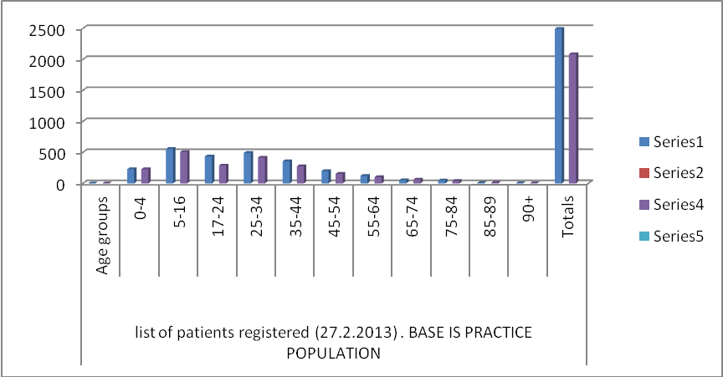

PRACTICE PROFILE 2012

ENGAGEMENT OF PATIENT GROUP
To engage patients to take part in the Patient Group the practice the following action was taken to invite patients from all ages ethnic background
- Poster displayed in waiting room/Notice Board
- Face to Face invite by admin staff and clinical staff to
- Letters
- Word of Mouth
- Patients contacted by telephone
Practice Engagement with under-representative communities

- Speakers from Support Plus
- Health Exchange
- Doctors and Nurses
- Health Care Assistant
- Multidisciplinary Team Feedback to Patients
- Patient Group Representative

