Greet Medical Practice
Patient FFT survey report October 2019 till March 2020
Based on the information received by our patients from the FFT survey that we distributed we have calculated data and have looked at the overall experience of the patients at the practice.
This report is based on the following data that we have collected
- Friends and Families Survey data
The practice strives to achieve better patient experience and satisfaction and continues to work on any areas that require improvement. From the feedback we have established improvement points and are continuously working towards improving the service we offer to our patients.
We have a very transient list with a high ethnic minority population, We aim to provide a high quality of service according to our patient’s needs, the survey is a crucial part of this as the feedback helps us to better understand how we can improve are services. It also provides a better understanding and relationship between the primary care staff and the patients.
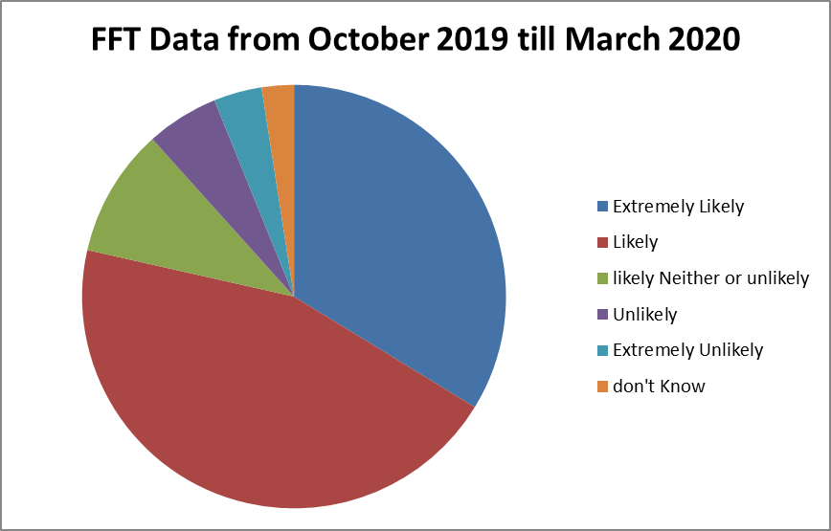
Extremely likely | likely | Neither likely or unlikely | Unlikely | Extremely unlikely | Don’t know
55 | 73 | 16 | 9 | 6 | 4

COMMENTS AND FEEDBACK
The following comments are from patients who indicated that they were happy for these to be made public. All comments are included in their entirety but all attempts have been made to remove details which could identify specific patients or practitioners.
Positive Comments
- Always helpful deal with respect provide good service
- Friendly and helpful
- Very friendly and helpful surgery
- Everyone is really helpful and always there to help
- New patient that has joined family, No delay or waiting on waiting list
- Receptionist very supportive, tried to make sure I got an urgent a/p
- Outstanding doctors and staff, always getting seen on time and with the highest customer service.
- Fairly good
- Appointments are given mostly same day
- Can get appointments and doctors see patients properly
- Receptionist staff is very friendly & extremely helpful. They are always happy to assist called in for urgent a/p booked me in straight away
- Fantastic Doctors
- Great service always polite and try their best to get me an appointment when required
- Outstanding receptionist, very understanding
- The service was nice & quick. Receptionists are always lovely & helpful whilst also being busy. Mrs Kaur was helpful and nice seeing my nervousness
- The staffs at the practice are always happy to help and always go out their way to meet my needs no matter how big or small.
- Very helpful
- Most of the times seen. Promptly by reception and whomever the appointment is with. Overall good service
Comments based on areas of improvement
- Difficulty getting appointment
- Unable to get appointment on the same day Minimum 2 week wait
- Don’t get a/p when needed.
- You don’t have an option to order medication over the phone or sending medication to near pharmacy. Once I had to wait for 1 hour for an a/p

Analysis of data
80% of patients are extremely likely and likely to recommend the practice to friends and families.
20% of patients are neither likely nor unlikely, unlikely and extremely unlikely to recommend the practice to friends and families.

Positive comments regarding access, caring and concern from doctors, nurse and receptionist.
Comments regarding areas of improvement where generally about booking routine appointments and one comment about accessing medication over the phone. GP partner is currently on maternity leave therefore patients are being seen by a regular locum. On analysis of the appointment system there where sufficient appointments available but the practice will look into how this can be improved to increase patient satisfaction.
Accessibility to appointments
•Access online – We have improved our online access from 10% to 20% allowing patients to access appointments online. We continue to encourage our patients and educate them to use the online access so they are able to utilise the service that is available to them. The Bsol and Birmingham and Solihull app has a symptom checker which allows the patient to check there symptoms online and will guide them to the appropriate service.
•Extended Access hours – The practice now has extended access hours where patients who can’t come in during the practice hours are able to come in extended access times. This is both in the practice and a local HUB. The practice extended hours are Monday 6:30pm to 8:30pm and Thursday 6:30pm to 7:30pm. The smart care federation are open 5 week day evenings & weekends. This is beneficial to the patients and the practice as well as primary & secondary care reducing A&E attendance.
•Patient participation group discussion – In the practice we have a PPG discussion about utilising appointments and what other services are available such as over the counter medication, walking in centre. Extended access appointments etc. The practice will continue to do the above mentioned points to improve patient satisfaction.
•Telephone Consultations – Patients are able to book in telephone consultations with the GP if in shortage of face to face appointments. The practice has increased the number of telephone consultations.
Staff Training
•In-house training – The practice has implemented in house training to educate the staff members on how to utilise the appointments system in a more efficient way. The practice has a future plan to continue this training.
•Staff Meetings – The practice will continue to have more staff meetings combined with both medical & non-medical staff to discuss any changes or areas that we could improve on in regards to appointments.
•More staff – We have now got more staff to answer the telephones at busy times. This will help the number of telephone calls answered during the day and improve the quality of the phone system
•New telephone system – the practice has a new telephone system in place. The system has a call waiting option to improve accessibility for patients calling the practice. The practice will audit patient satisfaction with the new telephone system.
Issues to address
- Patients experience of booking an appointment
Currently 2/3rd of our appointments are routine and 1/3rd emergency booked on the day. Patient can book in 4 weeks in advance. Dr JA will be visiting local practices to see what appointment system works best and implementing this system into the surgery.
- Improvements made at the practice
MJog – The practice has introduced new SMS systems in which allows us to text patients and informs them of any services they are due for as well as send reminders for their appointments. This improves the communication between the practice and patients.
Future plan
The practice is moving towards having video consultations with GPs which will enhance the service by giving it an extra way to access the service. The plan is to get this up and running in April 2020. This plan of the practice is designed to maximise the efficiency of clinical time, reduce inappropriate demands on urgent care service, improve overall access and integrate service.

