Greet Medical Practice
Patient FFT survey report April 2019 till Sep 2019
Based on the information received by our patients from the FFT survey that we distributed we have calculated data and have looked at the overall experience of the patients at the practice.
This report is based on the following data that we have collected
- Friends and Families Survey data
The practice strives to achieve better patient experience and satisfaction and continues to work on any areas that require improvement. From the feedback we have established improvement points and are continuously working towards improving the service we offer to our patients.
We have a very transient list with a high ethnic minority population, We aim to provide a high quality of service according to our patient’s needs, the survey is a crucial part of this as the feedback helps us to better understand how we can improve are services. It also provides a better understanding and relationship between the primary care staff and the patients.
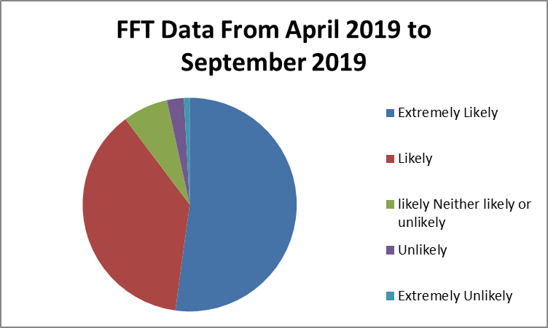
Extremely likely | likely | Neither likely or unlikely | Unlikely | Extremely unlikely | Don’t know
61 | 44 | 8 | 3 | 1 | 0

COMMENTS AND FEEDBACK
The following comments are from patients who indicated that they were happy for these to be made public. All comments are included in their entirety but all attempts have been made to remove details which could identify specific patients or practitioners.
Positive comments
- Good Drs, Nice receptionists
- Drs very good and receptionist cooperative. Very good
- The staff is always helpful
- Because they listen carefully and answer all my questions and satisfied me.
- Very pleasant staff good and understanding GP
- Able to get same day appointment nice and clean environment
- Good medical centre, receptionists is really nice and always looks after you. However the centre can be improved if it was easier to book app
- the staff are very friendly and provide good service especially the reception staff are exceptional Doctors are great/ brilliant
- it’s close to our house and the doctors are nice
- very helpful and efficient staff
- the staff and the doctors are very helpful I recommend this surgery strongly
- easy to get emergency appointment
- Great service always helpful. Into solving the matter. Excellent and prompt in action
- Get appointment or emergency appointments on the day. Friendly staff, drs and nurses take their time and explain in detail. Get the help you need.
- I have been a long standing patient at the GP and I have seen it improve a lot.
- Quick solutions/appointments
- they are extremely professional as well they try to give appointment as quick as possible

Comments based on areas of improvement

- Not being able to get appointment*
- service is hit and miss, never know until the day app hard to get*
- Good medical centre, receptionists is really nice and always looks after you. However the centre can be improved if it was easier to book app*

*comments are from Aprils Families and friends test

Analysis of data

90% of patients are extremely likely and likely to recommend the practice to friends and families.

10% of patients are neither likely nor unlikely, unlikely and extremely unlikely to recommend the practice to friends and families.

Positive comments regarding access, caring and concern form doctors, nurse and receptionist.
All comments that were not so positive were received in April 2019. However this was the month that the practice had moved back into Greet Medical Practice after a flood. No negative comments were received from June onwards. All areas of improvement relate to booking appointments, to address this area the practice has improved access online extended access hours and have increased number of face to face appointments and telephone triage. June 2019 to date there has been no negative comments regarding booking an appointment.

Accessibility to appointments
•Access online – We have improved our online access from 5% to 10%, from July 2019 allowing patients to access appointments online from different groups. We continue to encourage our patients and educate them to use the online access so they are able to utilise the service that is available to them. The Bsol and Birmingham and Solihull app has a symptom checker which allows the patient to check there symptoms online and will guide them to the appropriate service.
•Extended Access hours – The practice now has extended access hours from July 2019 where patients who can’t come in during the practice hours are able to come in extended access times. This is both in the practice and federation. The practice extended hours are Monday 6:30pm to 8:30pm and Thursday 6:30pm to 7:30pm. The smart care federation are open 5 week day evenings & weekends. This is beneficial to the patients and the practice as well as primary & secondary care reducing A&E attendance.
•Patient participation group discussion – In the practice we have a PPG discussion about utilising appointments and what other services are available such as over the counter medication, walking in centre. Extended access appointments etc. The practice will continue to do the above mentioned points to improve patient satisfaction.
•Telephone Consultations – Patients are able to book in telephone consultations with the GP if in shortage of face to face appointments. The practice has increased the number of telephone consultations with Dr.RM to help the demand. This is beneficial to the elderly community, student and parents who may not be able to come into the practice.

Staff Training
•In-house training – The practice has implemented in house training to educate the staff members on how to utilise the appointments system in a more efficient way. The practice has a future plan to continue this training.
•Staff Meetings – The practice will continue to have more staff meetings combined with both medical & non-medical staff to discuss any changes or areas that we could improve on in regards to appointments.
Telephone accessibility
•More staff – We have now got more staff to answer the telephones at busy times. This will help the number of telephone calls answered during the day and improve the quality of the phone system
•New telephone system – the practice is looking to get a new telephone system which should be up and running November 2019. This will have a call waiting option to improve accessibility for patients calling the practice.
Issues to address
The practice changed patient experience when booking an appointment at reception following some verbal suggestions from patients. Patients found the reception area very busy at certain times in the day. To address this issue the practice changed the way the front line staff deals with patients face to face. Previously receptionists where answering telephone calls and dealing with patients face to face. The practice has now implemented change in May 2019 whereby there has been an increase in the number of receptionists answering the phone in the back office and one receptionist does not answer calls at front desk.

MJog – The practice has introduced new SMS systems in August 2019 which allows us to text patients and informs them of any services they are due for as well as send reminders for their appointments. This improves the communication between the practice and patients.

Future plan
The practice is moving towards having video consultations with GPs which will enhance the service by giving it an extra way to access the service. The plan is to get this up and running in April 2020. This plan of the practice is designed to maximise the efficiency of clinical time, reduce inappropriate demands on urgent care service, improve overall access and integrate service.

